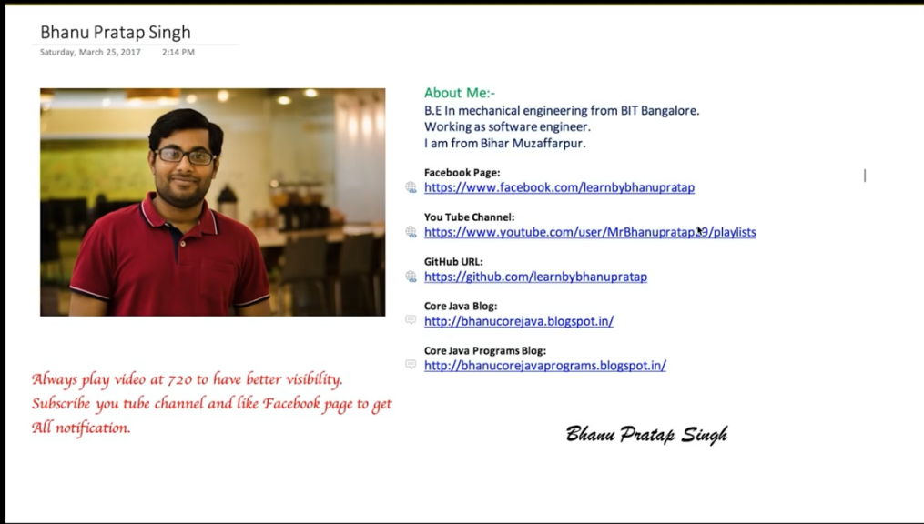

Create Project Structure (Just the base—we will evolve as we progress more)

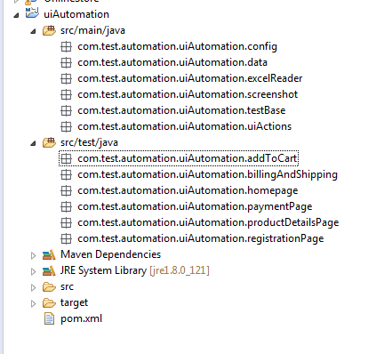

Video#2

First Test Script Modularized

Test Case

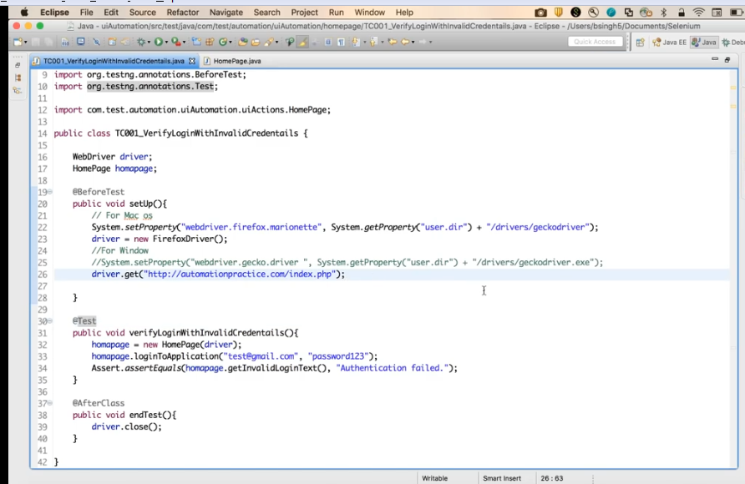

Action Class

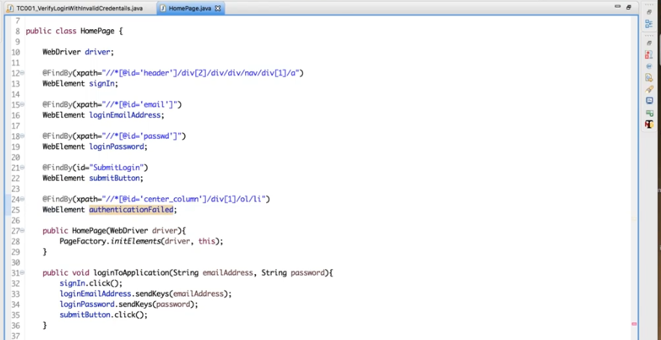

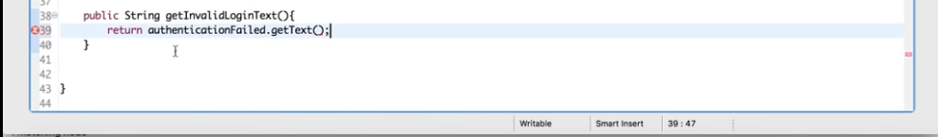

Video#3

In this session we learn how to perform setup and endTest using TestBase Class.

TestBase class serves as parent class for all the test script classes

It basically contains init() method which calls all the methods for initialization defined within TestBase class.

All test scripts needs to extend TestBase class in order to utlize the functionality written into TestBase

Sample: TestBase Class (Note: This will evolve more and more further)

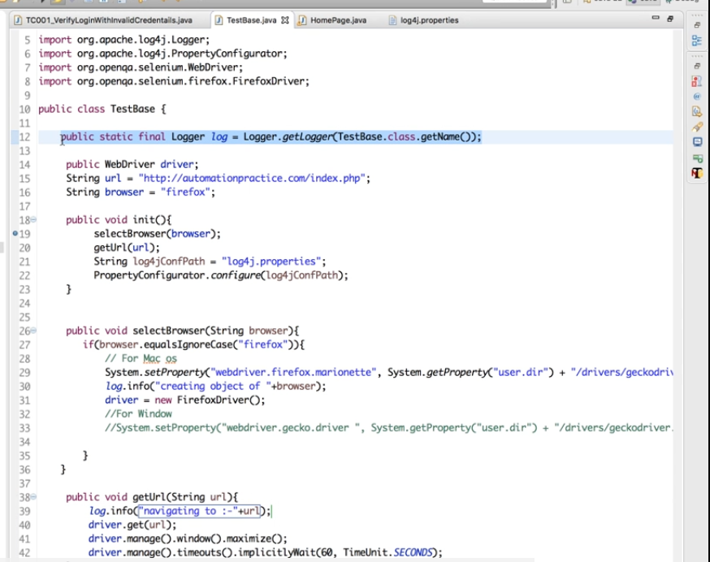

Action Class with Log4j implemented

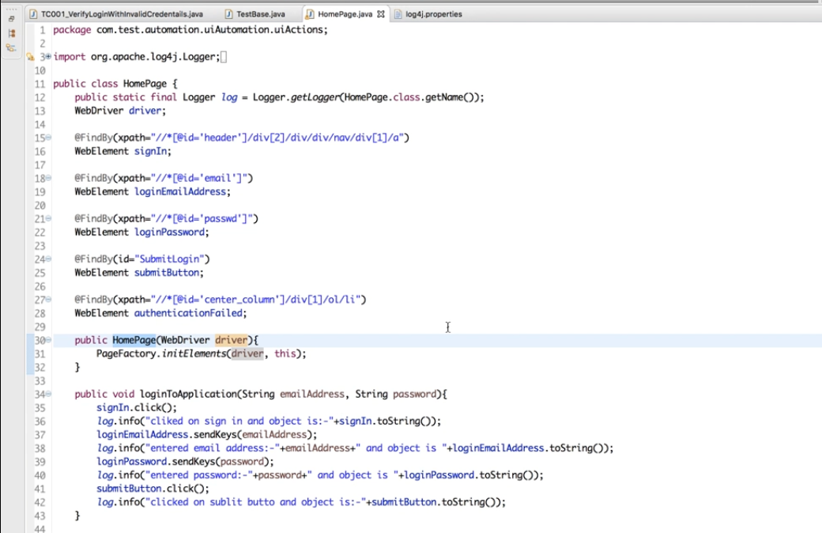

Test Script Class Becomes

Now we are just calling init() method of TestBase Class which will serve the purpose of all the initializations defined.

Also note that we have initialized logger for testscript class as well.

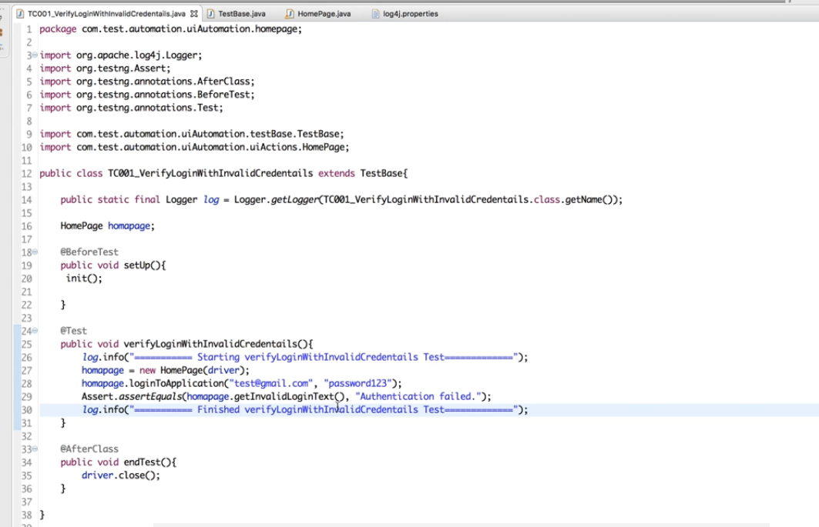

Output Sample Log4j yields as

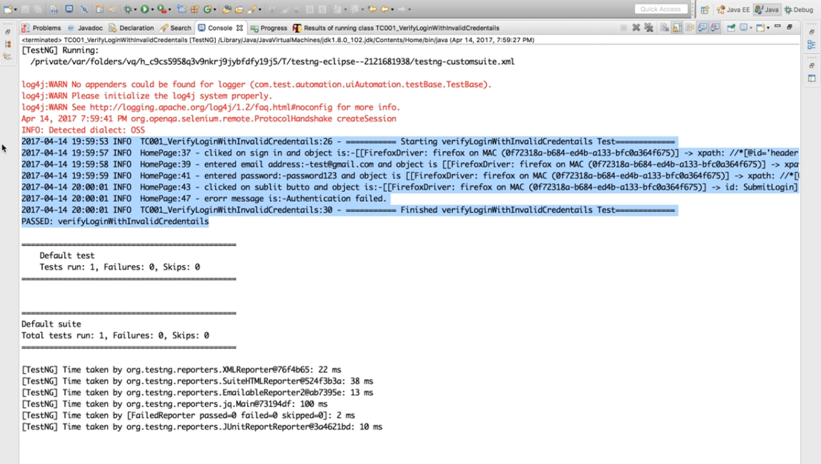

Video 4 to be continued . . . . .